P.O. Box 5205 Youngstown, Ohio 44514 Email: sales@skimtech.com
Phone: (330) 774-5044 Fax: (330) 757-7606 Website: www.skimtech.com

Product Overview

Skimall™ Model BG34 “Lucy” High Speed Skimming System

The Model BG34 Oil Skimming System is designed to remove free-floating oils, fats, grease and other material from the surface of water in indoor and outdoor applications. Typical applications include “tramp oil” removal from central coolant systems, waste water treatment oil/water equalization tanks, outdoor oil/water separators, settling and cooling ponds and hundreds of other applications.

How The Skimmer Works:

The Model BG34 Oil Skimmer uses a specially formulated ¾” diameter collector tube (TigerTube™) that is sized in length for the application and welded into a continuous loop. The ¾” TigerTube™ collector tube floats on the surface of water and is driven in a continuous loop by the skimmer. Oils, fats, and grease cling to the outside surface of the TigerTube™ and are drawn into the skimmer. The material drawn into the skimmer is scraped off the TigerTube™ by abrasive resistant scrapers (Dureon™ scrapers) and flows into a sludge pan with drain coupling. The clean side of the TigerTube™ collector tube is then driven back to the surface of the water by the skimmer to remove more material.

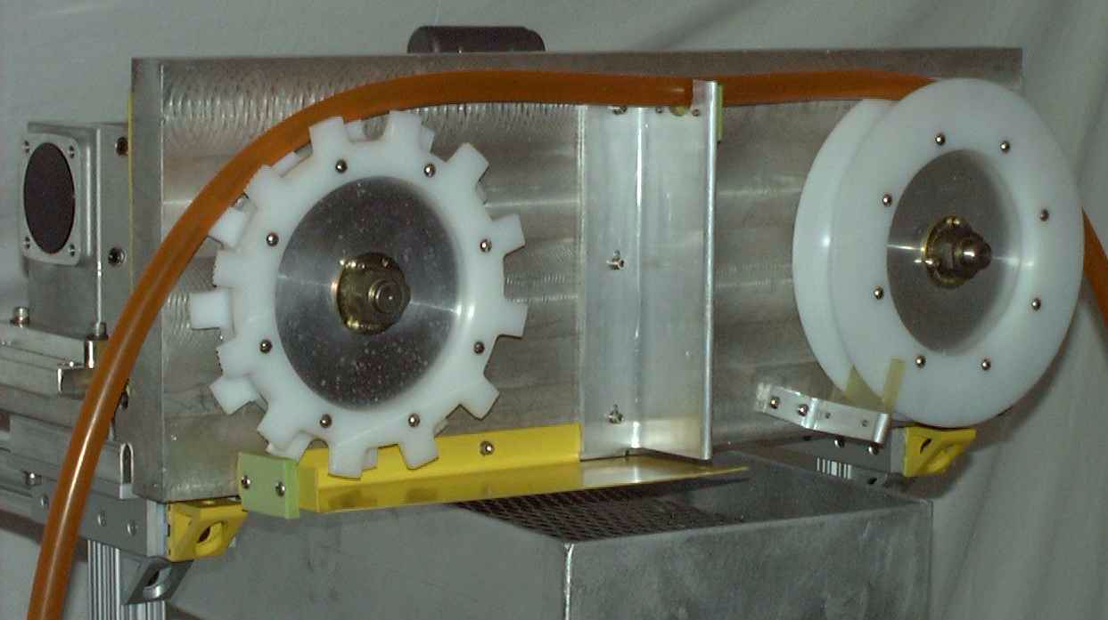

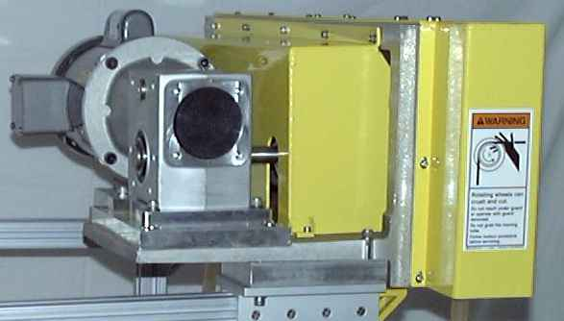

Typical Removal Rates:

- Light Oils & Grease - 20 GPH
- Medium Oils & Grease - 50 GPH
- Heavy Oils & Grease - 120 GPH

The Model BG34 Oil Skimming System Is Supplied Complete With:

* 1/2 HP 115/230Volt single phase motor or 230/460 Volt three phase motor.
* Safety guard with integral Dureon™ scrapers & pressure blocks.
* Lubed for life gear reducer, bearings and sprockets.
* Quick connect and release Drive and Pulley Wheels.
* Single ring replaceable Dureon™ Drive and Pulley Wheel Wear Rings.
* Modern Drive and Pulley Wheel timing belt drive system with belt tension device.
* Rear safety guard.
* Weight - 140 lbs.
* Dimensions (Length x Width x Height) - 36” x 20” x 12”.

Skimmer Mounting Systems:

SkimTech has an assortment of standard frame and boom mounting systems available for any application. Custom mounts that include pumps, 500 - 2000 gallon collection tanks, and complete system controls are available for unique customer requirements. Any mounting system can be winterized for outdoor applications. Our Application Engineering Department is available to assist with any customer application.

Performance And Quality Guarantee:

Every SkimTech product is sold with an unconditional performance and quality guarantee that ensures total customer satisfaction. Details concerning the guarantees can be found on our website at www.skimtech.com.

Miscellaneous Information:

SkimTech, Inc. skimmer designs are patented. Skimall™, TigerTube™, and Dureon™ are registered trademarks of SkimTech, Inc.

